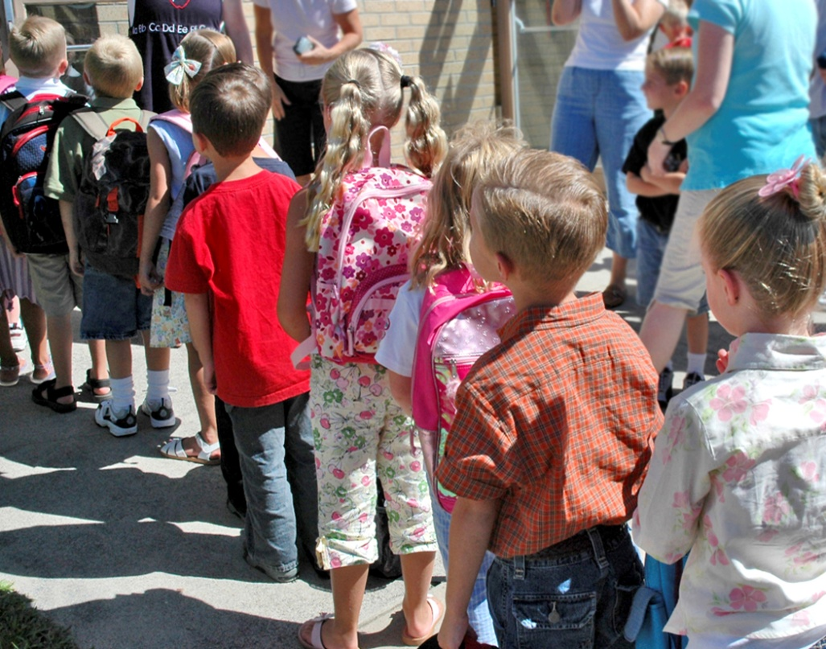
Welcome!!
The school year is starting again! I’m so glad that your student is a part of our community. Every child that walks through our doors contributes something unique and important to our classroom. This year brings a new place with many new faces, so I welcome you to Hartford. I hope this information helps you understand more about the Hartford school and our 4th grade program. Please also read the Hartford Handbook for more information. I am very excited to begin the year! Mrs. Folsom
Parent/Teacher Communication
Good communication between parent/teacher is very important to student success. I encourage you to communicate with me through e-mail, phone, notes, and in person. If I am unavailable for some reason, I will get back to you as soon as possible. I will be maintaining a classroom website and several social media accounts to keep you informed about events and units that we will be covering. We will also be having parent/teacher conferences two times this year to provide you with information about how your student is progressing in the classroom. Please feel free to contact me whenever you have a concern about any part of your child’s education.
IPOD Binders and Planners
Your student’s IPOD binder and planner will travel between school and home each day. You will find important school information, notes, and daily work. There may be a request for a permission slip or book order. I check them consistently each morning so feel comfortable putting any information for me in the binder or planner. Make it a habit to bring it signed every day!
Students will have a planner to fill out each day. I will check their planners at the end of the day on their way out the door. After their homework is finished, students are to get a parent/guardian’s signature for that day. I will check them again the next morning.

Water Bottles and Snacks
Students are encouraged to bring water bottles into the classroom. Students will be allowed to fill up their bottles before class starts in the morning and during bathroom breaks. Please only bring water bottles with attached lids. Through the day we will also have a time for snacks; students are encouraged to have a healthy snack at this time, we have a long morning until lunch. Please see our district’s guidelines for food being brought to school.
Book Order
Scholastic Book Orders will be sent home with students every month. The students will have time to look over the selections and bring back the purchase slip. The due dates will be on the form and also on the monthly calendar located on our website. Online ordering will also be available from Scholastic. The website is scholastic.com/bookclubs and our class activation code is GTPHB, when you order online we get free books for our class! Please do not feel obligated to purchase books. This is just another opportunity to add to your home library and encourage reading for your student.

Behavior Expectations
Positive behavior is a big focus at Hartford. Within our school day students are taught what is expected from them in different parts of the building and encouraged when they follow these expectations. This policy will follow us into our own room; positive behavior will be commended. In the first few weeks of school we will be working hard to learn and practice the routines that will make our daily classroom interactions run smoothly.
Late Work
Your student should complete any homework sent home and return on the correct date. If any student has three or more missing or late assignments per week they will receive an office referral. Missing work will be made up during recess and a note will be written in their planners to let you know.
Monthly Reading Logs and Book Goals
A classroom expectation is to read 100 minutes per week. Our classroom will also be working on a yearlong “More than Before” challenge – with our goal being to read more than we’ve read in any other school year.

Schedule
8:00 – Bus 12 leaves the elementary for Hartford
8:15 – School starts in Hartford
9:10 – 4th grade specials
Day 1 – Media
Day 2 – P.E.
Day 3 – Art
Day 4 – Music
Day 5 – Technology
Day 6 – Guidance
12:05-12:30 – Recess
12:35-12:55 – Lunch
3:15 – Buses leave Hartford
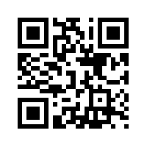
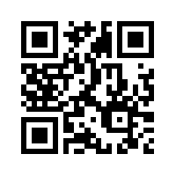
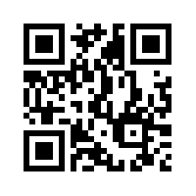
Class Website and Twitter
Our class will be using Twitter and a website to tell our families what we’ve been working on. Subscribing to our Twitter updates on your computer or smart phone (@FolsomRoom108) would be a great way to have conversations with your child about what they are learning during the day. Even though technology can sometimes be intimidating (for me too!) taking the time to check out this resource might be a great way to bring school into your home! I will also be taking some information about what types of social media you personally use, so I can best meet the needs of the adults in our class.
Our Learning Community
In room 108 learning is our number one priority. We take this job very seriously and will experience much success throughout this year. We will support each other through this process. Our classroom will offer a safe space for all to take chances and grow as citizens and students. The year will be filled with friends, active learning, and hard work!
Again please contact me with any questions or concerns. Thank you!
Sincerely,
Jill Folsom
Scan for our website
Scan for our Twitter page
Scan for my contact info.

School phone – (515) 989-0316 ext.5739 Email – jill.folsom@carlisle.k12.ia.us

