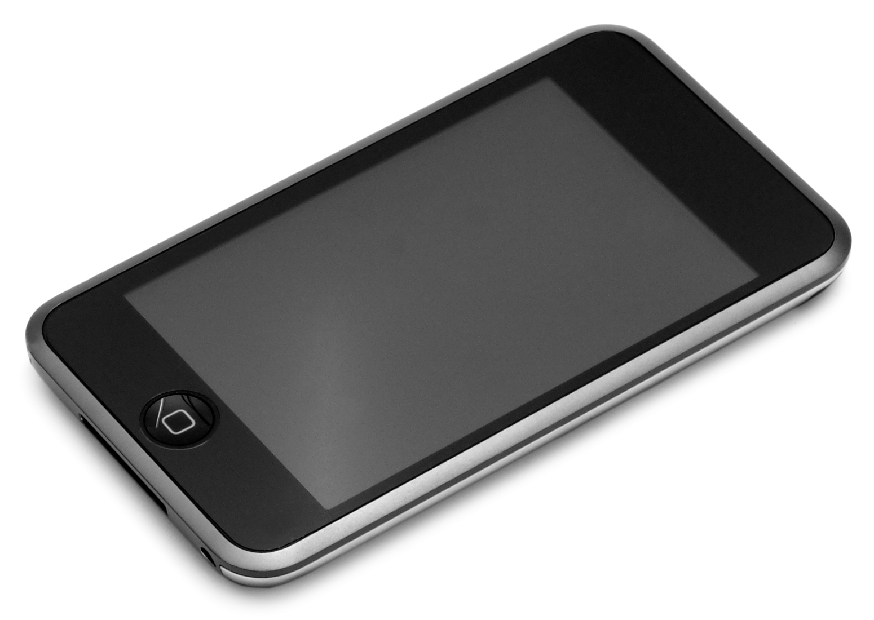

iPOD
I’m Prepared and Organized Daily

Fourth Grade Family,
This year your student will carry their iPod binder to and from school every day. The binder is used to promote organization and responsibility in your student and streamline communication between home and school. Student binders will be updated daily at the end of the school day and should be checked, planners signed, and papers taken out nightly.
The contents of the binder will be put together at school on the first day and will remain the same throughout the year.
Homework Folder – this folder is where any homework or important notes will travel between school and home nightly.
Planner – students will fill out their planner every day, a parent/guardian should sign by the corresponding day. These will be checked each morning.
Take Home Envelope – on Mondays a manila envelope will be sent home with all checked papers, tests, or classroom notes. These should be emptied and returned on Tuesday morning.
Mrs. Folsom’s and Hartford’s Contact information
Please assist your student in keeping their iPod binder organized and easy to use!
Thank you for your help!
Mrs. Folsom

