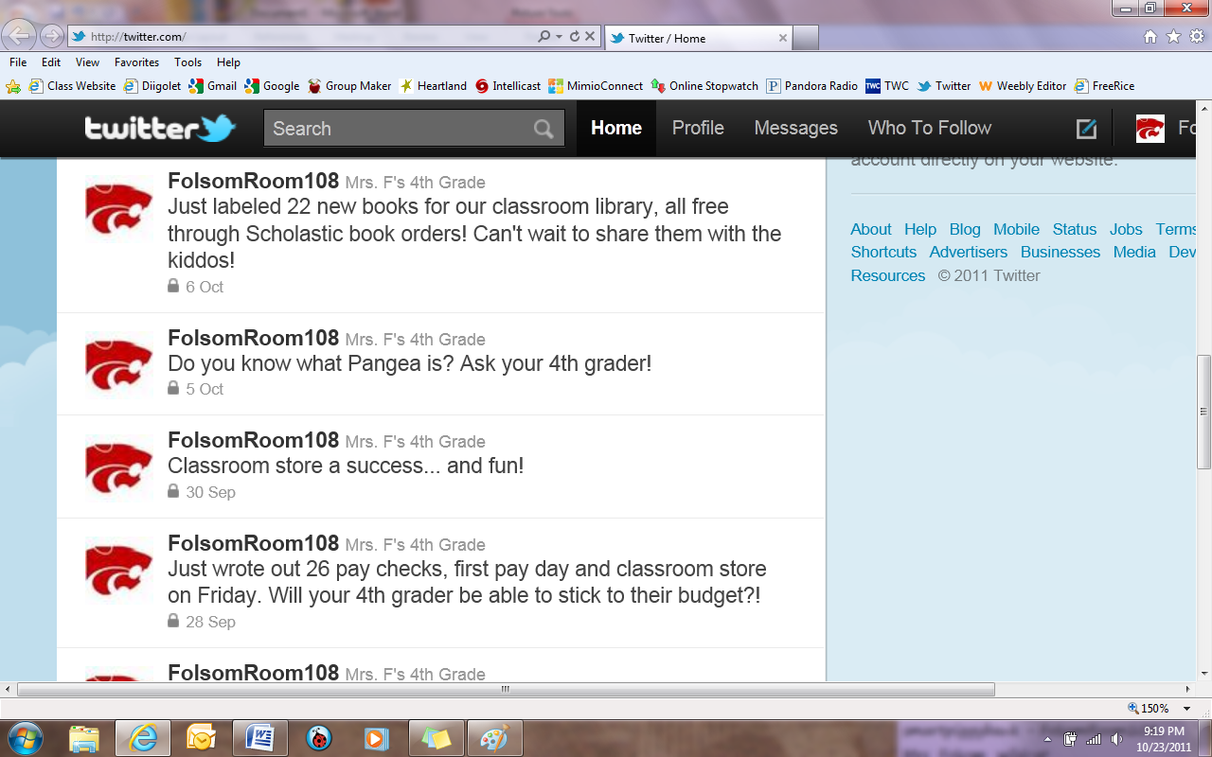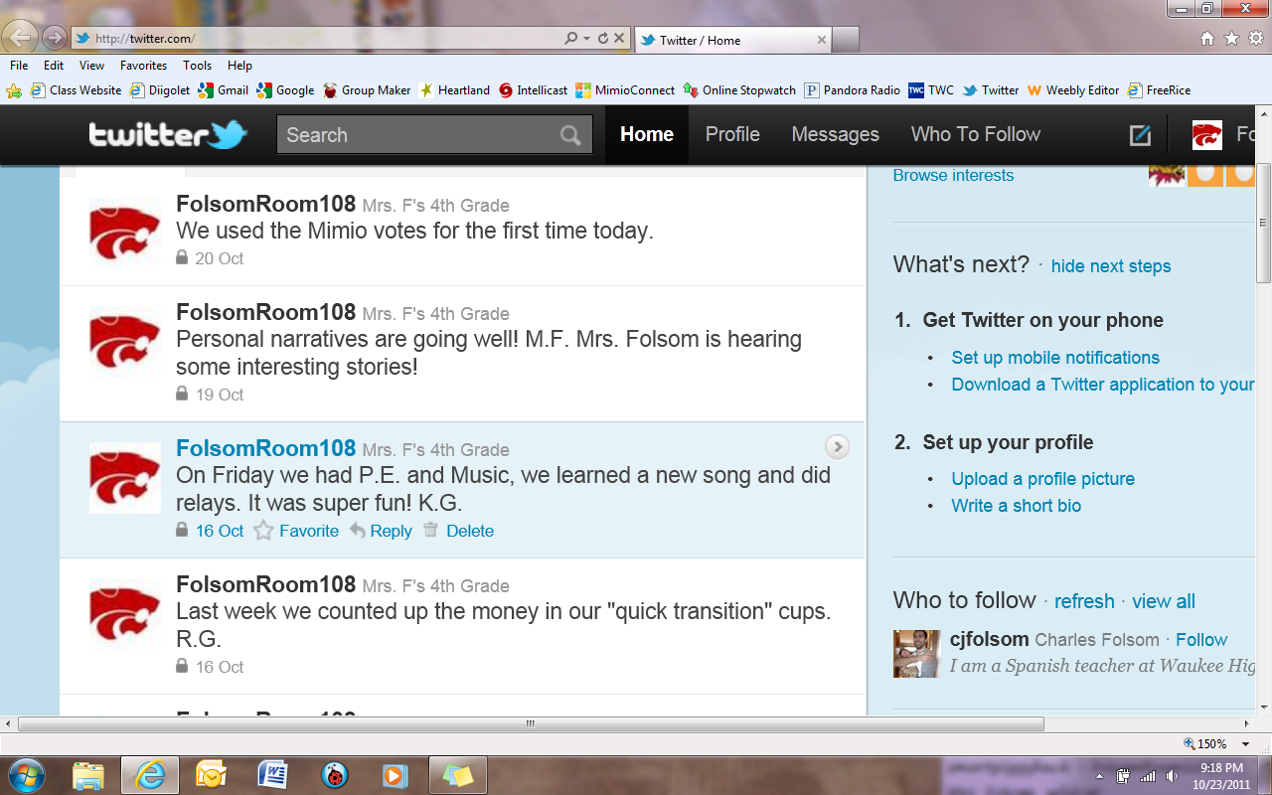

Do you wonder about what your student is doing during the day in 4th grade? Get multiple daily updates written by students by following our class on Twitter.  
  
1. Visit [www.twitter.com](http://www.twitter.com) and sign up for an account.  
2. Follow FolsomRoom108.  
3. Receive our Tweets on your smart phone, visit twitter.com, or our classroom website.   
4. Have conversations with your 4th grader about what is going on in their school life!